Nightriders Web Site – The Guide

Contents

The Link 1

Opening Page 2

Current League Walkthrough 3

Historical Results Walkthrough 5

Appendix A – Reading the Standing Sheet 6

Appendix B – Reading the Weekly Sheet 7

Appendix C – Reading Your Individual Sheet 8

Appendix D – Reading Your Long Term Individual Sheet 9

## The Link

Case sensitive - <https://glennmur.github.io/Nightriders/index.html>

## Opening Page



Scroll down to see the options

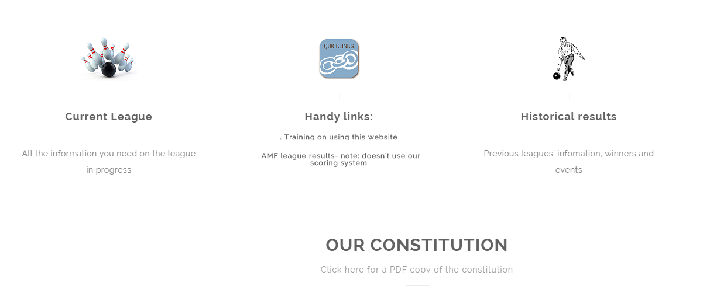

The committee details further down



## Current League Walkthrough

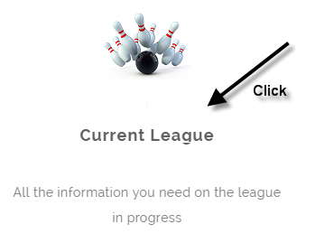 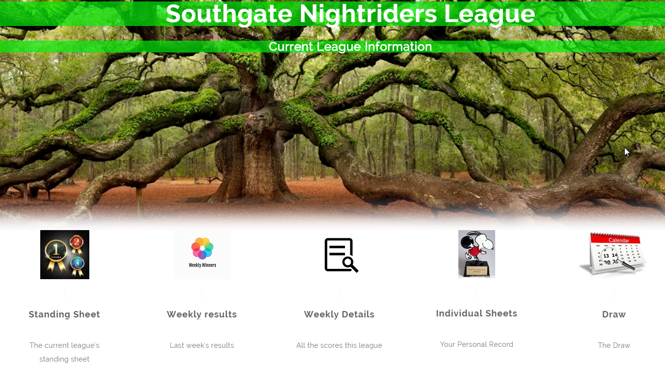

Do you want to see where you are placed in the season? Check out the Standing Sheet

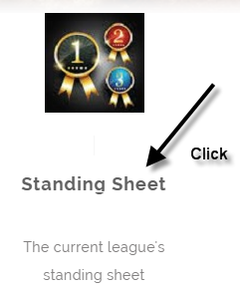 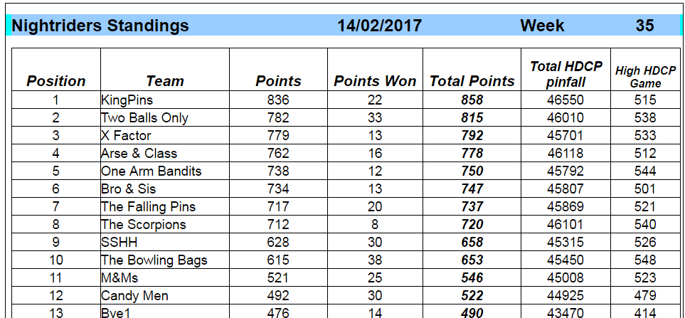

Go here to learn more -> Appendix A – Reading the Standing Sheet

Do you want to double-check how you did last week? Read the Weekly Sheet

 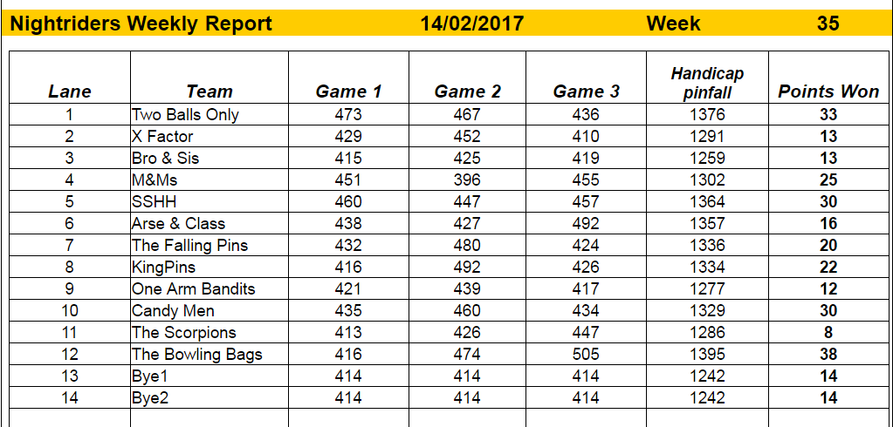

Go here to learn more -> Appendix B – Reading the Weekly Sheet

Do you want to poke around more, try this analysis tool with details of all games bowled in the current league

 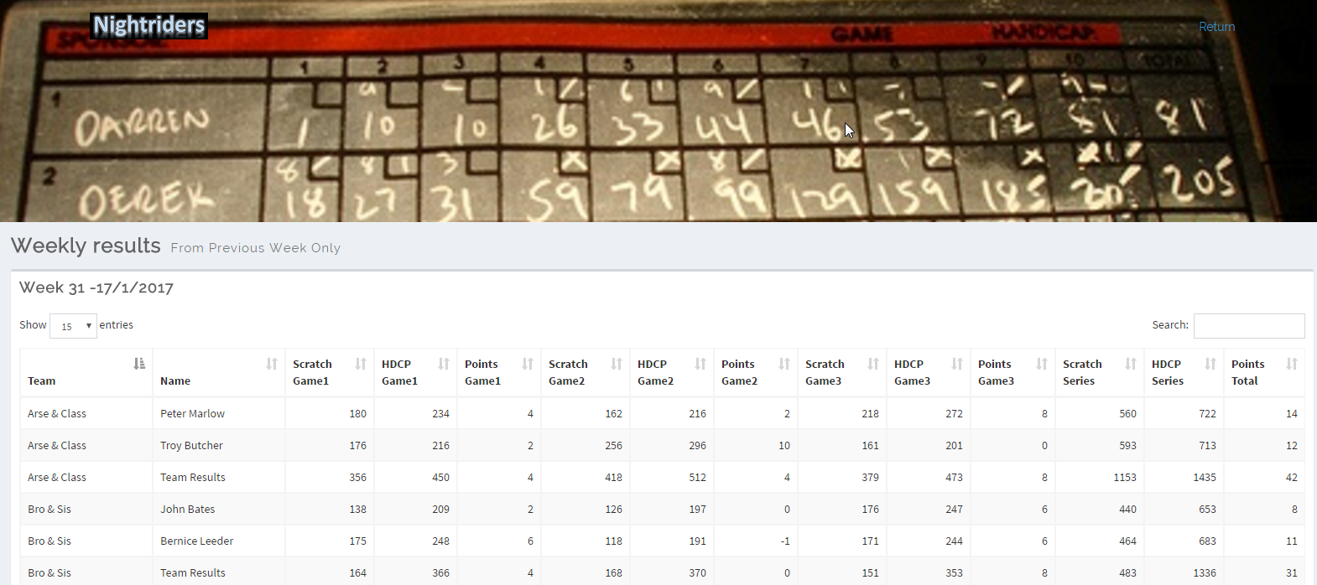

How about yourself? Your individual sheet is now updated each week

 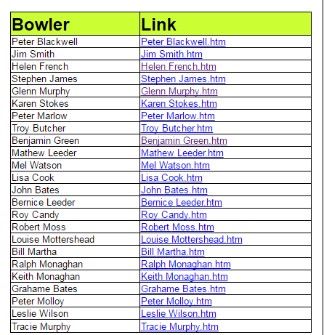 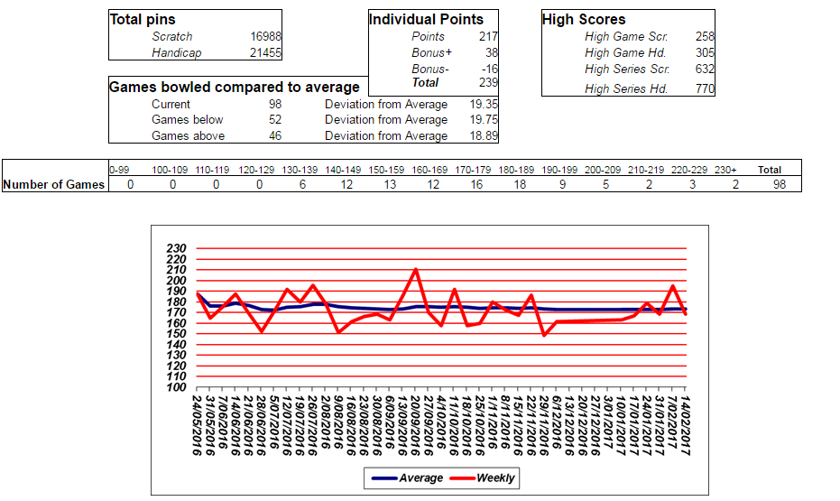

Go here to learn more -> Appendix C – Reading Your Individual Sheet

Who are you bowling against next week? Check the draw

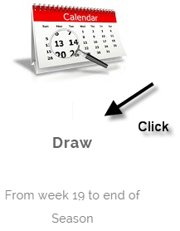 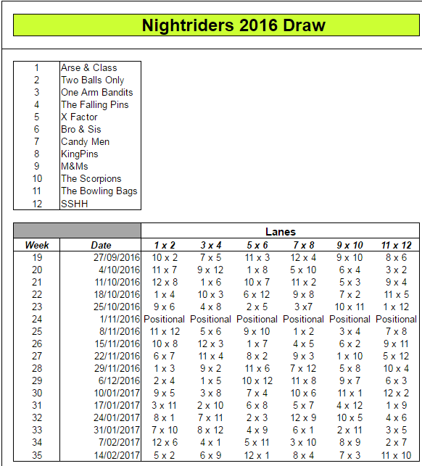

## Historical Results Walkthrough

 

Who has won the competition before? Going back to 2008

 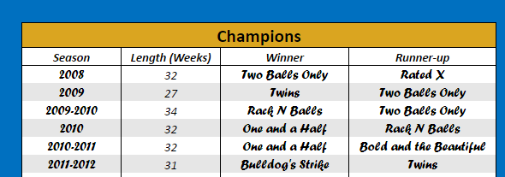

Who has bowled the highest each season? (not necessarily the person who won the prize)

 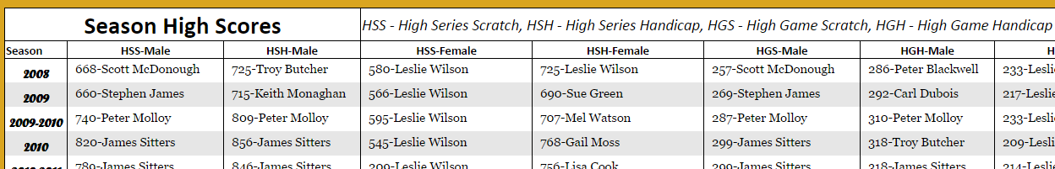

How about yourself? Your individual sheet since 2008!

 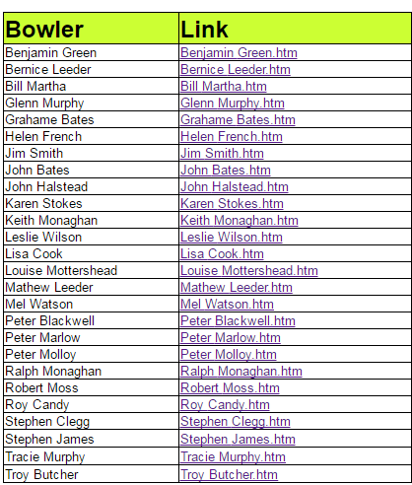 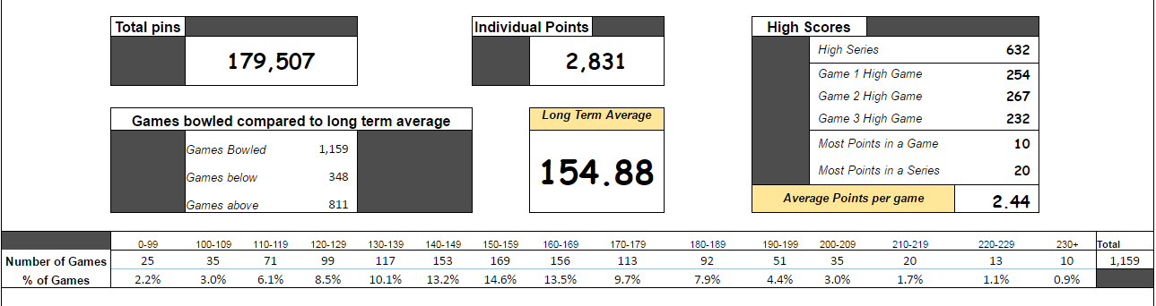

Plus detailled information from past leagues

Go here to learn more -> Appendix D – Reading Your Long Term Individual Sheet

## Appendix A – Reading the Standing Sheet

|  |  |
| --- | --- |
| Points | Points carried forward from the previous weeks |
| Points Won | Points won in the current week – in this example week 35 |
| Total Points | Addition of ‘Points’ and ‘Points Won’ – the sheet is sorted by this column |
| Total HDCP pinfall | All ‘Scratch + Handicap’ for the season |
| High HDCP Game | Highest ‘Scratch + Handicap’ game for this season |

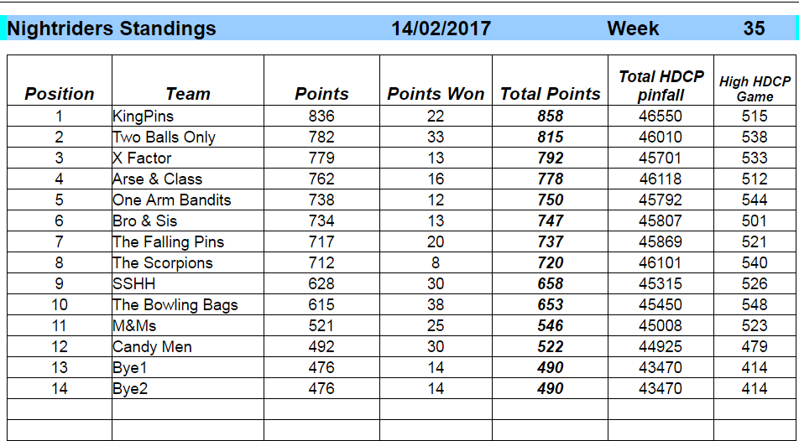

|  |  |
| --- | --- |
| High Series | Current 1st and 2nd scores for all the series based money prizes |
| High Game | Current 1st and 2nd scores for all the single game based money prizes |
| Points | Individual points – only a small prize for Total Individual winner |
| League Game Average | Average game of all players added together |
| Average team game | Average score of all team games including handicap |
| Average team series | Average score of all team series including handicap |
| Average weekly Points | Average points won for all teams added together |

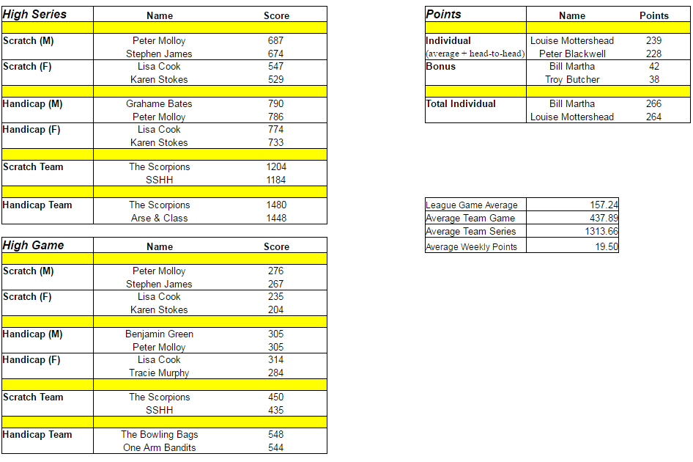

|  |  |
| --- | --- |
| Notes | Occasional notes on upcoming events |
| Averages/Handicap | Information on blinds, byes, forfeits and vacancies |
| All bowlers | Each bowling with current Average/Handicap |

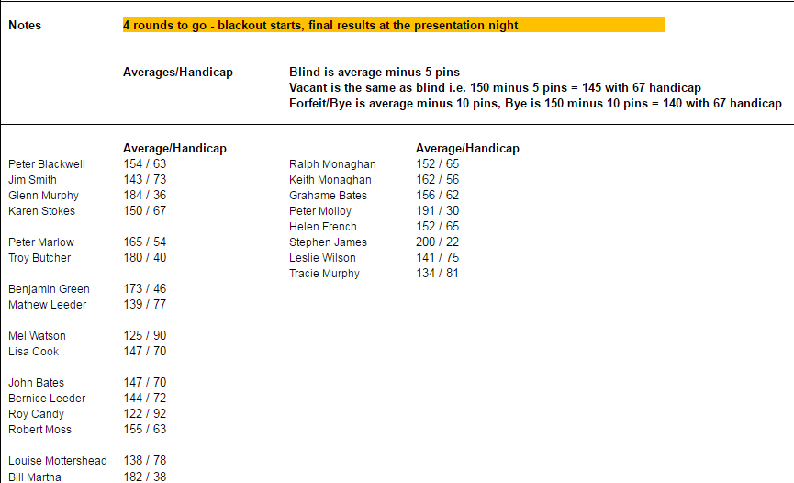

## Appendix B – Reading the Weekly Sheet

|  |  |
| --- | --- |
| Game 1 / 2 / 3 | Team ‘Scratch + Handicap’ game scores |
| Handicap pinfall | ‘Scratch + Handicap’ series for this round |
| Points Won | Total Points for this round |

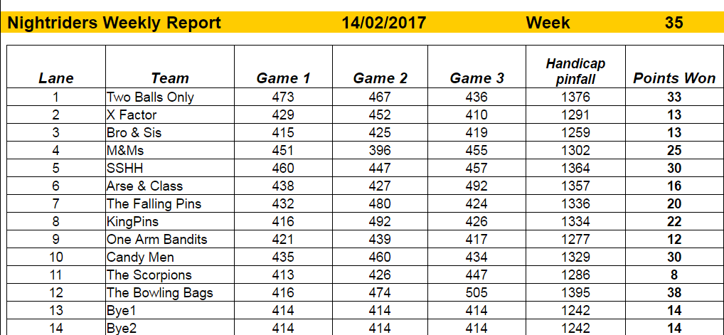

|  |  |
| --- | --- |
| High Series | 1st and 2nd series scores this week |
| High Game | 1st and 2nd game scores this week |
| Points | Highest Individual points this week |
| Average team game | Average score of all team games including handicap this week |
| Average team series | Average score of all team series including handicap this week |
| Average weekly Points | Average points won for all teams added together this week |

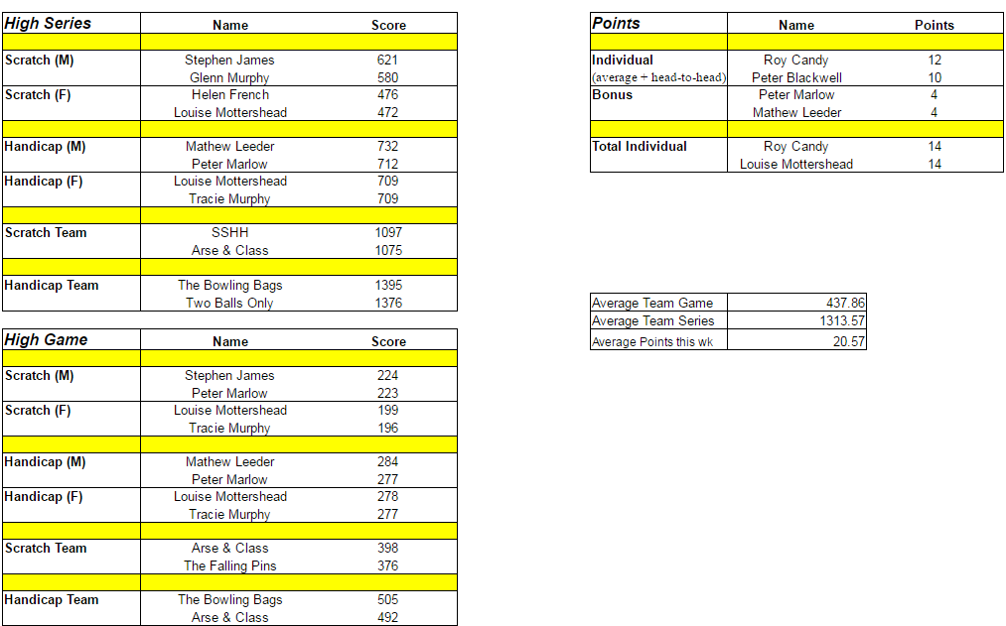

The point system explained

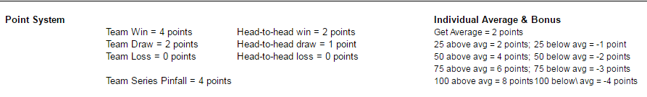

How the points are calculated for each game

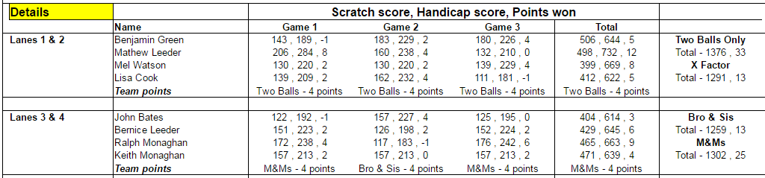

Walkthrough an example – lanes 1 & 2:

* The three numbers are ‘Scratch score’ , ‘Handicap score’ , ‘Points won’
  + Game 1:
    - Ben bowled 143 scratch, 189 with handicap and got -1 points (for 25 below avg)
    - Mathew bowled 208 scratch, 284 with handicap and got 8 points (2 for avg, 2 for head-to-head, 6 for 75 above avg)
    - Mel bowled 130 scratch, 220 with handicap and got 2 points (for avg)
    - Lisa bowled 139 scratch, 209 with handicap and got 2 points (for head-to-head)
    - Team Points – Two balls got 4 points
  + Total:
    - Ben bowled a 506 series, 644 with handicap and got 5 individual points
    - Mathew bowled a 498 series, 732 with handicap and got 12 individual points
    - Mel bowled a 399 series, 669 with handicap and got 8 individual points
    - Lisa bowled a 412 series, 622 with handicap and got 5 individual points
  + Last column
    - Two Ball Only got 1376 total with handicap and 33 point (5+12 individual + 4+4+4+4 team points)
    - X Factor got 1291 total with handicap and 13 point (8+5 individual + 0 team points)

## Appendix C – Reading Your Individual Sheet

|  |  |
| --- | --- |
| Total Pins | Scratch and Handicap this season |
| Individual Points | Points you have earned this year |
| High Scores | Your best games and series this season |
| Games compared | Current – all games compared to average |
|  | Below – number of games below and compared to average |
|  | Above – number of games above and compared to average |

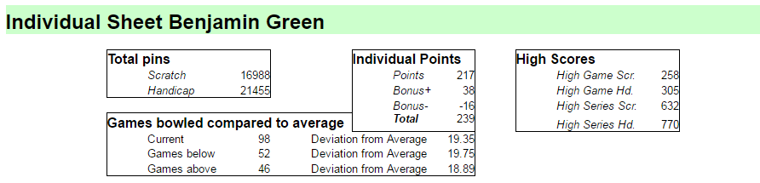

Deviation from average explained by an example:

* You bowled 3 games – 140 , 176 , 200 - your average is 172
  + Game 1 is 32 below average, game 2 is 4 above average and game 3 is 28 above average
  + Current will be: 3 games, Deviation from average is 21.33 (32+4+28)/3
  + Games below will be: 1 game, Deviation from average is 32
  + Games above will be: 2 games, Deviation from average is 16 (4+28)/2

All games you have bowled in ranges



Your blue line average and your red line weekly series

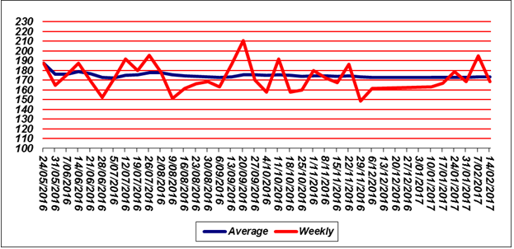

All the games you bowled highlighting your best performances

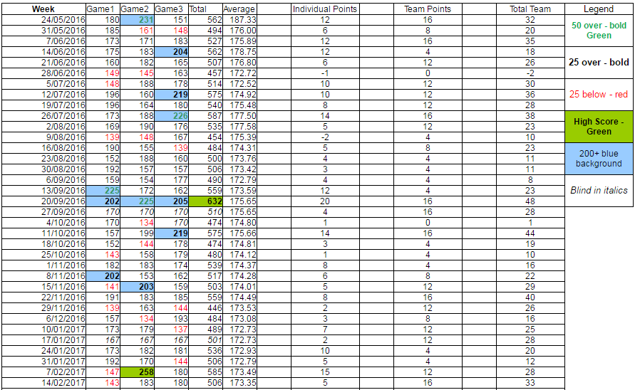

## Appendix D – Reading Your Long Term Individual Sheet

|  |  |
| --- | --- |
| Total Pins | Scratch Pins your have bowled since 2008 |
| Individual Points | All the Points you have earned since 2008 |
| High Scores | Your best games and series since 2008 |
|  | Points earned and avg points earned per game |
| Games compared | Games bowled and above/below you average |
| **Long Term Average** | The big one! The average of all your games |

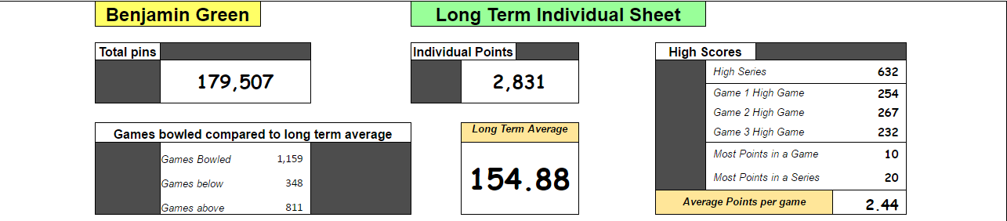

All games you have bowled in ranges



Your blue line average and your red line weekly series 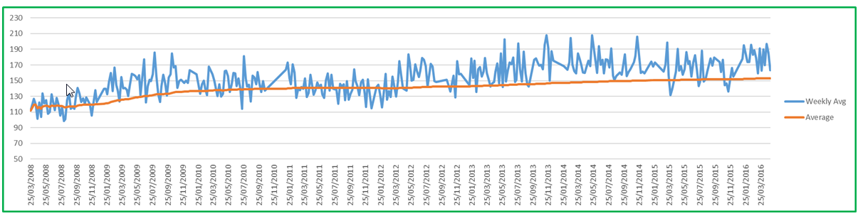

The detail – all the games you ever bowled in Nightriders since 2008

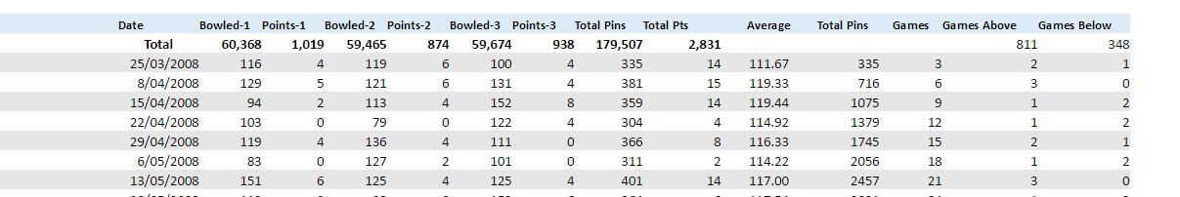

You can highlight this data and copy to your own spreadsheet if you want to take a copy

|  |  |
| --- | --- |
| Bowled-1, Bowled-2, Bowled-3 | Games 1,2,3 scratch – no blind scores are included |
| Points-1, Points-2, Points-3 | Games 1,2,3 points - no points when bowled blind are included |
| Total Pins | Your scratch series |
| Total Points | Points earned |
| Average | Your running average |
| Last 4 columns | Used to calculate total numbers |